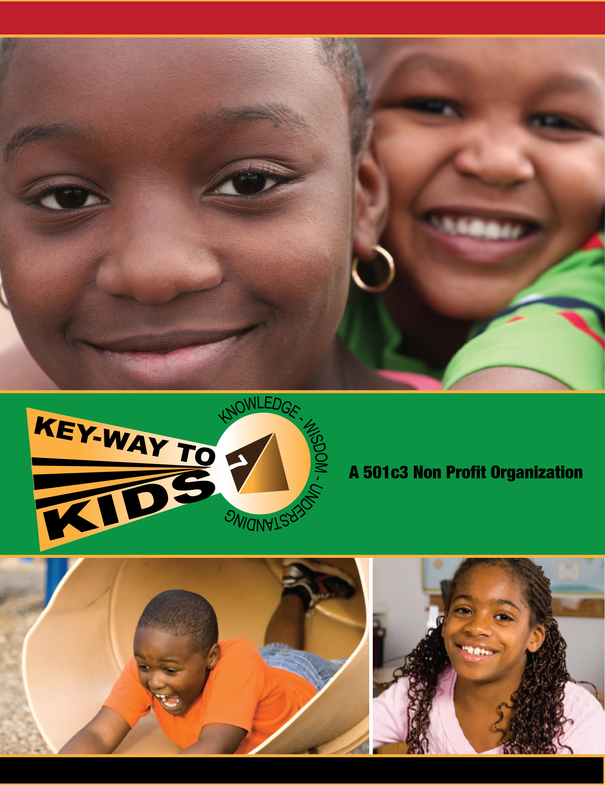

YWAV.ORG

Key Way to Kids

(non-profit org.)

WHO: Creative Kids ages (8-14)

WHAT: It’s a 6 Week Course in Multi Digital Media & Broadcasting

WHEN: Nov.14th, 2012

TIME: After-School (5 – 7:30pm)

WHERE: WOW CHURCH

14111 E.7mile@Gratiot

City2Citytv

14111 E.Seven Mile RD @ Gratiot DETROIT,Mi 48205

* @ THE WOW CHURCH

WHY: TO ENHANCE JOB OPPORTUNITIES TO DETROIT YOUTH

Twitter

Facebook

Marketing

BROUGHT TO YOU BY:

MISSION: TO BRING COMPUTER LITERACY, FINANCIAL AWARENESS, SELF IMPROVEMENT, AND SELF ENRICHMENT TO UNDER-PRIVILEGE TEENS AND AT RISK YOUTH FROM AGES 8-18….

THE SEATS ARE LIMITED ***** CLASSES WILL FILL UP FAST SO PLEASE DON’T HESITATE.

$100 For 6 Week Session on Wednesday 5 to 7:30pm

ADULTS CLASSES COMING SOON-Sign Up @ [City2Citytv@gmail.com](mailto:City2Citytv@gmail.com) or City2Citytv.com

AFTERSCHOOL DIGITAL MEDIA classes

LIVE

BROADCASTING

T-Shirt

Making

Photoshop

CALL FOR REGISTRATION 248.247.4244 C.POPE

SHOOT FILM, NOT PEOPLE (48205)

**Financial**

**Literacy**

FILM

Video Making

Garage band

Fruit loops

Beat Making

Animation

WEB SITE

DEVELOPMENT

# Mauris ante urna, congue in, venenatis eu, dictum vel, justo. Donec neque. Nam tincidunt leo a nisi placerat congue. Sed nonummy, diam non ornare auctor, enim elit commodo ipsum, in dapibus pede nisl nec urna. Donec dictum facilisis turpis. Donec quis ipsum. Maecenas quis odio eu erat lacinia sodales.